**R Code for Examples in the book**

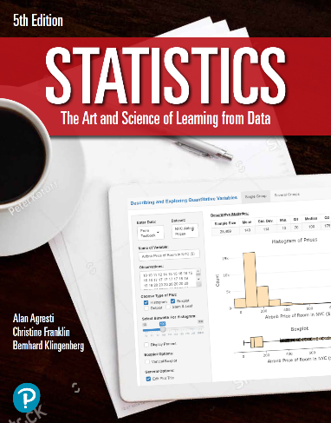

***“Statistics: The Art and Science of Learning from Data”***

**by Agresti, Franklin and Klingenberg, 5th edition**

**Chapter 13**

**Example 10: House Selling Price – Indicator Variables**

## Reading in data

houses <- read.csv(file='https://raw.githubusercontent.com/artofstat/data/master/Chapter13/house_selling_prices_or.csv')

## Fitting in multiple regression model

linReg <- lm(House.Price..USD.~ House.Size + Condition, data = houses)  
summary(linReg)

##   
## Call:  
## lm(formula = House.Price..USD. ~ House.Size + Condition, data = houses)  
##   
## Residuals:  
## Min 1Q Median 3Q Max   
## -312024 -33585 -852 28105 382876   
##   
## Coefficients:  
## Estimate Std. Error t value Pr(>|t|)   
## (Intercept) 96270.971 13464.912 7.150 1.66e-11 ***  
## House.Size 66.463 4.682 14.196 < 2e-16 ***  
## Condition 12926.940 17196.712 0.752 0.453   
## ---  
## Signif. codes: 0 '***' 0.001 '**' 0.01 '*' 0.05 '.' 0.1 ' ' 1  
##   
## Residual standard error: 81790 on 197 degrees of freedom  
## Multiple R-squared: 0.5062, Adjusted R-squared: 0.5012   
## F-statistic: 101 on 2 and 197 DF, p-value: < 2.2e-16